Forecasting Taxi Times

By Tim Durand

Contents

Overview of the data source 2

Objective 2

Introduction to time series forecasting 2

ARIMA (Autoregressive Integrated Moving Average Model) 2

Import and basic overview of a data sample 3

Prepare the full dataset 7

Examine the Data 8

Resample the data 10

Time bands 11

Decomposition 12

Stationarity 13

Differencing 14

Augmented Dickey-Fuller test 16

Choosing the model order 17

Auto Regressive model analysis 17

Estimate the Order of the AR Model - Partial Autocorrelation method 18

Estimate the Order of the AR Model - Information Criteria methods AIC and BIC 18

Moving Average model analysis 20

Estimate the Order of the MA Model - Autocorrelation method 20

Fitting and evaluating the model 21

Train the model with each combination of parameters 22

Plot the forecast of each model 23

Conclusion 28

Resources 29

Appendix 30

Data Dictionary 30

# Overview of the data source

I have chosen a dataset published by the US Department of Transport's Bureau of Transportation Statistics. The dataset contains data for non-stop US domestic flights by major operators. It provides information on taxi-out and taxi-in times, departure and arrival delays, departure and arrival airports, flight numbers, departure and arrival times (scheduled and actual), flight status (cancelled or diverted), flight time and distance.

<https://www.transtats.bts.gov/DL_SelectFields.asp?Table_ID=236>

# Objective

The objective is to explore the On-Time Performance dataset and gain insight into Taxi Times. We have a customer driven requirement for information in this area, perhaps the insight discovered in this document could be used on private customer data, not in the public domain. The customer requirement is; for a given Departure Airport and month, forecast the taxi time per hour of the day. i.e. for next Month for JFK show me a forcast of the Taxi Out Time in minutes at time band 10am-11am, they would also like to know the forecast time for the month in general regardless of time of day.

The Taxi Out Time is the time in minutes between the departure time (when the aircraft leaves the gate), to take off (when the wheels leave the runway). Operators like to leave the gate on time as much as possible as this is the time that gets counted for delay purposes; sometimes an aircraft will leave the gate on time, then wait near the runway for an extended period of time, rather than the wait being at the gate itself mitigating a departure delay. However increased taxi-times cause cost in the form of fuel burn and a reduction in customer satisfaction.

# Introduction to time series forecasting

The task at hand is one of time series forecasting; time series data is a set of data points collected at time intervals. Past points in time for a given observation can be analysed to forecast future values, data can also be analysed more holistically to learn about the underlying processes generating it. A time series problem is different from a regular regression problem in a number of ways, the two main differences are:

* The basic assumption of a linear regression model is that the variables are independent of one another. However, a time series problem is dependent on a time component.
* Time Series data often has some form of seasonality as well as an increasing or decreasing trend, i.e. variation specific to a particular period in time. For example, Ice cream sales in the summer months will typically be higher than sales in winter.

## ARIMA (Autoregressive Integrated Moving Average Model)

I will explore the idea of using an ARIMA model for forecasting; an ARIMA model is a popular model for time series analysis and forecasting. When the model is used, a degree of differencing is applied to make the data stationary (to remove trend and seasonality that may negatively affect a regression model), a linear regression model is then created using specified parameters.

The model is made up of 3 key aspects; Auto Regressive, Integrated and Moving Average. These aspects are simply described as:

* AR: Auto regression - A model that uses the relationship between an observation at a point in time and one or more dependant observation(s) at previous time lag(s).
* I: Integrated - Differencing is used to eliminate trend and seasonality, making it stationary.
* MA: Moving Average - A model that uses the residual error from a moving average model applied to an observation and lagged observations.

The model takes 3 parameters: ARIMA(p,d,q) one for each key aspect of the model which control how the model operates. These are defined as:

* p - The number of lag observations included in the model, also called the lag order.
* d - The number of times that the raw observations are differenced also called the degree of differencing.
* q - The size of the moving average window, also called the order of moving average.

The model is designed to be used when the underlying process that generated the data is an ARIMA process, however if relevant, the model can be configured to perform the function of more simple AR, I, MA models or an ARMA combination model. If any of the p, d or q parameters are assigned a value of 0, that aspect is deactivated.

# Import and basic overview of a data sample

I have some prior knowledge of Python so I will be using this language to explore the data.

The website containing the source data only provides monthly downloads; because I will need to explore data from different months, I downloaded several files from the website. Due to the large size of each file, I will explore one file to begin with, get a feel for the data contained and decide if there is any information I can throw away before looking at several months’ data.

First I will import all the required libraries:

* #Import the required packages
* # Data manipulation
* **import** pandas as pd
* **import** numpy as np
* # Filehandling
* **import** os
* # Plotting
* **import** matplotlib.pyplot as plt
* plt.rcParams['figure.figsize'] = [8.0, 5.0]
* # Statsmodels libraries
* **import** statsmodels.api as sm
* **from** statsmodels.tsa.stattools **import** pacf
* **from** statsmodels.graphics.tsaplots **import** plot_pacf
* **from** statsmodels.tsa.seasonal **import** seasonal_decompose
* **from** statsmodels.tsa.stattools **import** acf
* **from** statsmodels.graphics.tsaplots **import** plot_acf
* **from** statsmodels.tsa.arima_model **import** ARIMA
* **from** statsmodels.tsa.stattools **import** adfuller

I then make one month’s data available as a dataframe using the read_csv method:

* firstfile = 'C:/Users/durandt/Documents/Aston/Data Sets/On-Time Data/csv/On_Time_On_Time_Performance_2017_1.csv'
* df1 = pd.read_csv(firstfile, low_memory=False)
* df1.head()

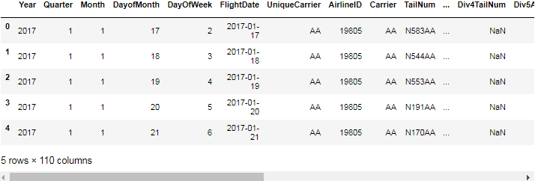

* # NULLs
* info=pd.DataFrame(df1.isnull().sum()).T.rename(index={0:'# NULL'})
* info=info.append(pd.DataFrame(df1.isnull().sum()/df1.shape[0]*100).T.rename(index={0:'% NULL'}))
* info=info.append(pd.DataFrame(df1.dtypes).T.rename(index={0:'type'}))
* AllNull = info.T
* AllNull = AllNull[AllNull['% NULL'] == 100]
* **print**("Columns with all nulls:")
* list(AllNull.index)

Columns with all nulls:

['Div3Airport', 'Div3AirportID', 'Div3AirportSeqID', 'Div3WheelsOn',

'Div3TotalGTime', 'Div3LongestGTime', 'Div3WheelsOff', 'Div3TailNum',

'Div4Airport', 'Div4AirportID', 'Div4AirportSeqID', 'Div4WheelsOn',

'Div4TotalGTime', 'Div4LongestGTime', 'Div4WheelsOff', 'Div4TailNum',

'Div5Airport', 'Div5AirportID', 'Div5AirportSeqID', 'Div5WheelsOn',

'Div5TotalGTime', 'Div5LongestGTime', 'Div5WheelsOff', 'Div5TailNum']

Accompanying the data is an html readme file containing the description for each column; I have formatted this into the table and added to the appendix for reference.

Based on the readme file information, the columns containing all null values (above) and the problem I'm looking to resolve, the following are potentially useful for an overview of the dataset:

Year, Quarter, Month, DayofMonth, DayOfWeek, FlightDate, UniqueCarrier, Origin, Dest, CRSDepTime, DepTime, DepDelay, TaxiOut, WheelsOff, Cancelled, Diverted

I will now gain some basic insight into the data.

* # Subset the data
* df1 = df1[['Year','Quarter','Month','DayofMonth','DayOfWeek','FlightDate','UniqueCarrier','Origin','Dest','CRSDepTime','DepTime'
* ,'DepDelay','TaxiOut','WheelsOff','Cancelled','Diverted']]
* # Show the count of flights per Operator
* df1['UniqueCarrier'].value_counts().plot(kind='bar', title='Flights by operator')
* plt.show()

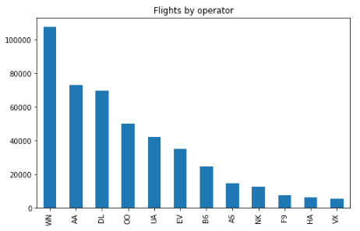

* **print**('Top 10 Origins')
* df1.groupby('Origin').agg({'Origin':'count'}).sort_values('Origin',
* ascending = False).rename(columns = {'Origin' : 'Count'}).head(10).transpose()

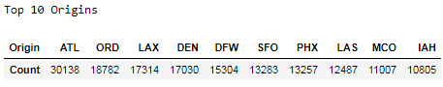

In order to simplify the problem and because of the high computational time on a large amount of data, for now I will look at American Airlines and JFK Airport. I will also remove any cancelled flights.

* **print**('Top 10 Origins for American Airlines')
* df1[df1['UniqueCarrier']=='AA'].groupby('Origin').agg({'Origin':'count'}).sort_values('Origin',
* ascending = False).rename(columns = {'Origin' : 'Count'}).head(10).transpose()

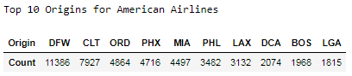

* df1 = df1[(df1.UniqueCarrier =='AA') & (df1.Origin =='JFK') & (df1.Cancelled == 0.0)]

I will now deal with the temporal munging of the data. Because there are multiple flights per day I suspect there will be seasonality based on the time of day each flight departs, as each Airport has its own Peak and Off-Peak times of day.

* **print**("For example - Number of Flights on 01/01/2017: "
* + df1[(df1.FlightDate =='2017-01-01')]['DepTime'].count().astype(str))

For example - Number of Flights on 01/01/2017: 54

I bin the data into hourly time bands and examine the counts per time band:

* # Create a function to retain only the hour portion of the timeband
* **def** converttimeband(time):
* **if** pd.isnull(time):
* **return** np.nan
* **elif** len(time) > 5:
* timeband = time[0:2]
* **elif** len(time) > 4:
* timeband = "0" + time[0:1]
* **else**:
* timeband = '00'
* **return**(timeband)
* # Create the Timeband column from Departure Time converted to a string
* df1['Timeband'] = df1['DepTime'].astype(str)
* # Apply the function to the new Timeband column
* df1['Timeband'] = df1['Timeband'].apply(converttimeband)
* # Show the count of flights departing in each Timeband
* df1[(df1.FlightDate =='2017-01-01')].groupby('Timeband').agg({'Timeband':'count'}).plot(kind='bar',sort_columns = 'Timeband', title = 'Count by time band')
* plt.ylabel("Flight Count")
* plt.legend(loc='best')
* plt.show()

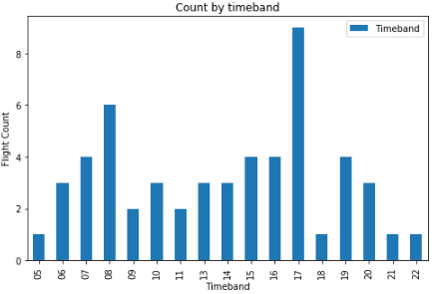

* # Show the mean of flights departing in each Timeband
* df1[(df1.FlightDate =='2017-01-01')].groupby('Timeband').agg({'TaxiOut':'mean'}).plot(kind='bar',sort_columns = 'Timeband', title = 'Mean by time band')
* plt.ylabel("Taxi Out Time Mean")
* plt.legend(loc='best')
* plt.show()

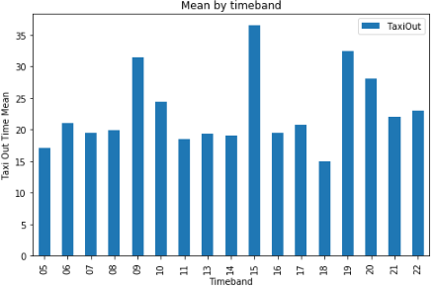

We can see from the flight counts chart that there are definite Peak and Off-peak times. The mean of the Taxi time varies a reasonable amount across time bands. A minute extra here or there can add up to tonnes of extra fuel being consumed over all. In order to produce a monthly prediction I am going to need to resample the data; the question is... should I resample all values in a month, or should I pivot the TaxiOut column into 24 features, one per time band then resample to monthly values. At least to begin with I will resample all values to a monthly mean.

# Prepare the full dataset

Now I have a brief understanding of a portion of the data I can import the full dataset in a cut down, memory friendly way.

I created a new FlightDate column from the 'Year', 'Month' and 'DayofMonth' columns, as the source files have different date formats for the FlightDate column, e.g. 2016-01-01 and 01/02/2016. The FlightDate and DepTime are then used to form a datetime component. I will keep the time band information and use the categorical variables to trim down the dataset to American Airlines and JFK Airport as before.

* # Combine all files with the cutdown list of columns
* datadir = 'C:/Users/durandt/Documents/Aston/Data Sets/On-Time Data/csv/'
* filelist = os.listdir(datadir)
* dfpart = [pd.read_csv(datadir + file, usecols = ['Year','Quarter','Month','DayofMonth','UniqueCarrier','Origin','DepTime','TaxiOut','Cancelled']) **for** file **in** filelist]
* df = pd.concat(dfpart,ignore_index=True)
* # Filter the data to AA and JFK
* df = df[(df.UniqueCarrier =='AA') & (df.Origin =='JFK') & (df.Cancelled == 0.0)]
* # Create a new FlightDate from the 'Year','Month','DayofMonth' as there are different formats of FlightDate across source files
* df['FlightDate'] = df['Year'].astype(str) + "-" + df['Month'].astype(str) + "-" + df['DayofMonth'].astype(str)
* # Create the Timeband column from Departure Time converted to a string
* df['Timeband'] = df['DepTime'].astype(str)
* # Apply the function to the new Timeband column
* df['Timeband'] = df['Timeband'].apply(converttimeband)
* # Remove the category columns that are no longer relavent
* df = df[['FlightDate','DepTime','TaxiOut','Timeband']]
* # Create the Time from DepTime converted to a string
* df['Time'] = df['DepTime'].astype(str)
* # Create a function to convert to time
* **def** converttime(time):
* **if** pd.isnull(time):
* **return** "00:00"
* **if** time == "2400.0":
* **return** "00:00"
* **elif** len(time) > 5:
* hrpart = time[0:2]
* minpart = time[2:4]
* **elif** len(time) > 4:
* hrpart = "0" + time[0:1]
* minpart = time[1:3]
* **elif** len(time) > 3:
* hrpart = "00"
* minpart = time[0:2]
* **else**:
* hrpart = "00"
* minpart = "0" + time[0:1]
* convtime = hrpart[0:2] + ":" + minpart[0:2]
* **return**(convtime)
* # Apply the function to the Time column
* df['Time'] = df['Time'].apply(converttime)
* # Combine the FlightDate with the formatted Time Column in a specfic format
* df['FlightDateTime'] = pd.to_datetime(df['FlightDate'] + ' ' + df['Time'], format='%Y-%m-%d %H:%M')
* # Remove the columns that are no longer required
* df = df[['FlightDateTime','TaxiOut','Timeband']]
* # Re-index the dataframe with the FlightDateTime
* df.set_index('FlightDateTime', inplace=True)

## Examine the Data

First of all I will visualize the data to further understand it and get an idea of the type of model I should use. Through this visualisation stage I hope to discover if there is an overall trend in the data and if there are there any seasonal trends. This is important when deciding which type of model to use and the required parameters for the model.

* df['TaxiOut'].plot(title = 'Taxi Out values' )
* plt.ylabel("TaxiOut")
* plt.xlabel("FlightDateTime")
* plt.show()

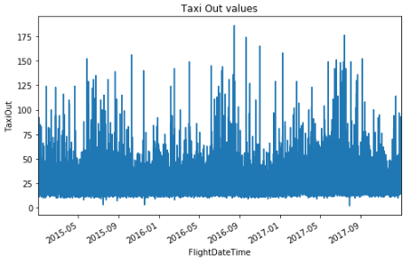

We can see from the above chart that the data needs to be resampled to be more meaningful.

* # Gain some statistical understanding
* df['TaxiOut'].describe()

count 51801.000000

mean 26.354800

std 13.298175

min 2.000000

25% 18.000000

50% 23.000000

75% 31.000000

max 186.000000

Name: TaxiOut, dtype: float64

* # NULLs
* info=pd.DataFrame(df.isnull().sum()).T.rename(index={0:'# NULL'})
* info=info.append(pd.DataFrame(df.isnull().sum()/df.shape[0]*100).T.rename(index={0:'% NULL'}))
* info=info.append(pd.DataFrame(df.dtypes).T.rename(index={0:'type'}))
* info

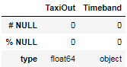

Interpolation is not required, as for the observations we are interested in there are no NULL values.

## Resample the data

Now I have some statistical awareness of the data and know that interpolation is not required at this stage, I can move on to resampling the data. As I am using per flight data (more frequent than daily) there is too much variation to determine trends; I will therefore resample the data using the mean. If I was looking at stock prices I may wish to use the last value in the month, I think for this purpose the mean is the most applicable. The resample function in python is similar to the rolling function but uses the date component instead of the frequency which I find quite convenient.

* dfd = df[['TaxiOut']].resample("D").mean()
* dfd['TaxiOut'].plot(color = "yellow", label = "Day")
* dfw = df[['TaxiOut']].resample("W").mean()
* dfw['TaxiOut'].plot(color = "red", label = "Week")
* dfm = df[['TaxiOut']].resample("M").mean()
* dfm['TaxiOut'].plot(color = "blue", label = "Month")
* plt.ylabel("TaxiOut Mean")
* plt.xlabel("Flight Date")
* plt.title("Resampled data")
* plt.legend(loc='best')
* plt.show()

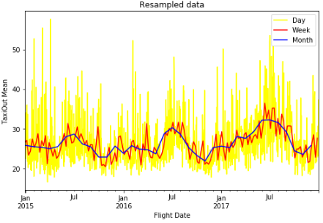

We can see from the above plot that there is a long-term upward trend in the monthly data, which is to be expected as the number of flights each year in general is increasing.. There is an annual seasonality with the summer months having a greater TaxiOut time than in winter. There are also weekly and daily fluctuations which could be due to a number of factors including weather, airline operational factors and news events etc. As I would like to predict the Taxi Out Time for a whole month I will look at the monthly resampled data in more detail.

## Time bands

I can have another investigation into the effect of time of day with the full data set.

* # Show the count of flights departing in each Timeband
* df.groupby('Timeband').agg({'Timeband':'count'}).plot(kind='bar',sort_columns = 'Timeband', title = 'Non-resampled data by time band')
* plt.ylabel("Flight Count")
* plt.legend(loc='best')
* plt.show()

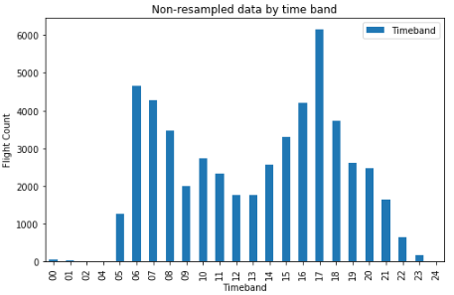

We can see obvious peak and off-peak times of day above.

I plot the monthly resampled data filtered by four example time bands below.

* plt.rcParams['figure.figsize'] = [8.0, 5.0]
* dfw5am = df[df['Timeband'] == '05'][['TaxiOut']].resample("M").mean()
* dfw5am['TaxiOut'].plot(color = "orange", label = "5am")
* dfd1pm = df[df['Timeband'] == '13'][['TaxiOut']].resample("M").mean()
* dfd1pm['TaxiOut'].plot(color = "black", label = "1pm")
* dfm5pm = df[df['Timeband'] == '17'][['TaxiOut']].resample("M").mean()
* dfm5pm['TaxiOut'].plot(color = "blue", label = "5pm")
* dfm6pm = df[df['Timeband'] == '18'][['TaxiOut']].resample("M").mean()
* dfm6pm['TaxiOut'].plot(color = "red", label = "6pm")
* plt.ylabel("Taxi Out Mean")
* plt.xlabel("Flight Date")
* plt.title("Taxi Out Mean by four example time bands")
* plt.legend(loc='best')
* plt.show()

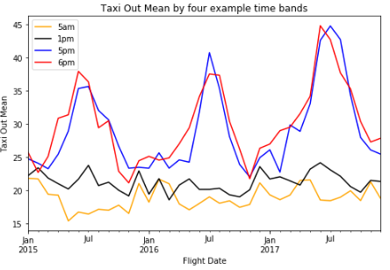

The Time bands at peak times, where most flights occur, can be thought of as principal components, contributing much more to the variation than the off-peak times which look much more random.

# Decomposition

According to Wikipedia, decomposition in time series is *“a statistical task that deconstructs a time series into several components, each representing one of the underlying categories of patterns."*

<https://en.wikipedia.org/wiki/Decomposition_of_time_series>

Below I use the seasonal_decompose tool from the statsmodels library; this is a useful tool to get a quick graphical representation of a naive decomposition.

According to the documentation on seasonal_decompose, *"The seasonal component is first removed by applying a convolution filter to the data. The average of this smoothed series for each period is the returned seasonal component."* <http://www.statsmodels.org/dev/generated/statsmodels.tsa.seasonal.seasonal_decompose.html>

* decomposition = seasonal_decompose(dfm.TaxiOut)
* plt.rcParams['figure.figsize'] = [8.0, 10.0]
* fig = decomposition.plot()
* plt.show()

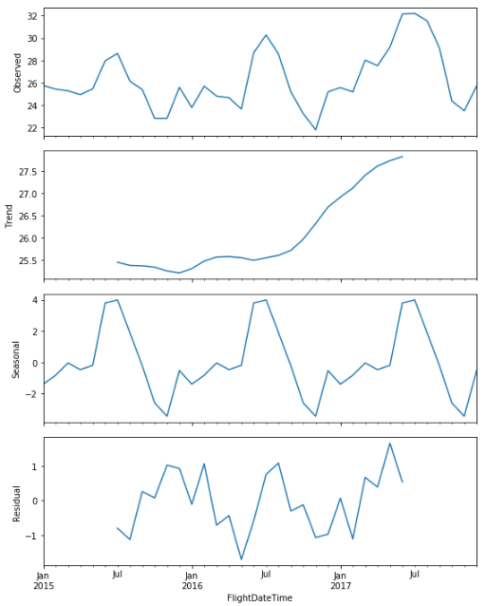

As before, we can see that there is indeed an upward trend over time, as well as seasonal variation and residual processes at work.

# Stationarity

In order for time series to be stationary; the mean, variance and covariance of the series should not be a function of time, i.e. its statistical properties should remain constant over time. If a process is not stationary it becomes difficult to model; modelling involves estimating a parameter and if a parameter is different over time then this means there are too many parameters to estimate. For example; linear regression models assume that all observations are independent of each other, however, with time series data, observations are time dependent. By Stationarizing data, regression methods can be applied to the time dependent variable.

I use rolling statistics to extract the trend element from the time series. We can see that the red line below is very similar to the trend line using the seasonal_decompose method.

* #Calculate rolling mean
* rolmean12 = dfm.rolling(window=12).mean()
* # Create two subplots sharing y axis
* plt.rcParams['figure.figsize'] = [8.0, 8.0]
* fig, (ax1, ax2) = plt.subplots(2, sharey=True)
* ax1.plot(rolmean12, color = 'black')
* ax1.set(title='Rolling Mean vs Trend from seasonal_decompose', ylabel='Rolling Mean')
* ax2.plot(decomposition.trend, color = 'red')
* ax2.set(xlabel='Date', ylabel='Trend')
* plt.show()

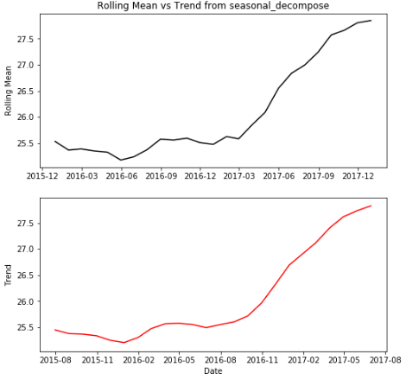

## Differencing

In order to get the residual data i.e. with the seasonal trend removed, I can take differences with a lag corresponding to the periodicity. I have used a differencing of 12 as I am looking at monthly resampled data. We can see that the red "differenced" line below is similar to the black "residual" line using the seasonal_decompose method; they are not exactly the same as the seasonal_difference function uses a different calculation method, but we can see the resemblance here. However if I use a difference of 1 it produces a much different result, it also produces an autocorrelation plot with none of the values outside of the 95% confidence area.

* # Difference the monthly data
* dfms = dfm.diff(1)
* dfms12 = dfm.diff(12)
* # Drop null values
* dfms = dfms.dropna()
* dfms12 = dfms12.dropna()
* plt.rcParams['figure.figsize'] = [8.0, 5.0]
* # Plot the differenced values
* dfms['2016-03-01':'2017-06-01'].plot(color = "blue", title ="Differenced (1)")
* plt.xlabel("Date")
* plt.show()
* # Plot the 12 differenced values
* dfms12['2016-03-01':'2017-06-01'].plot(color = "red", title = "Differenced (12)")
* plt.xlabel("Date")
* plt.show()
* #Plot the residual element of the seasonal_decomposition function
* decomposition.resid['2016-03-01':'2017-06-01'].plot(color = "black", title = "Residual")
* plt.xlabel("Date")
* plt.show()
* # plot the autocorrelation of the differenced 1 values
* plot_acf(dfms.TaxiOut, lags=20)

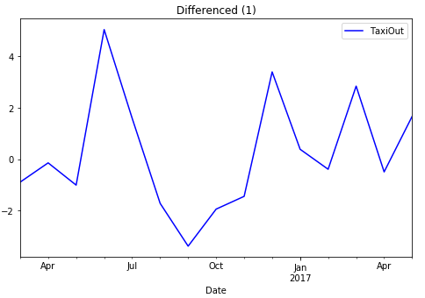

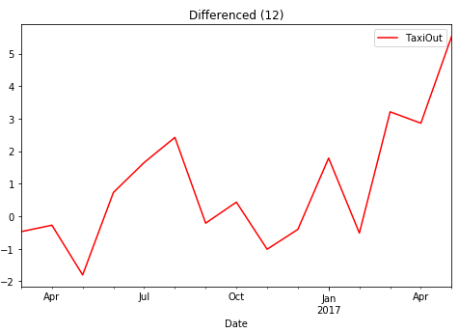

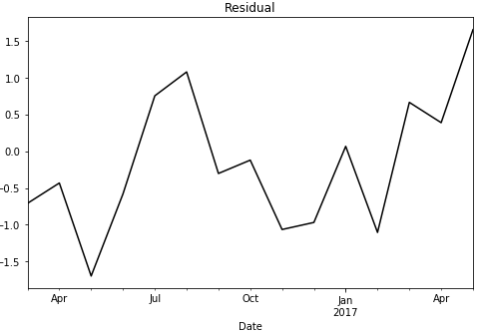

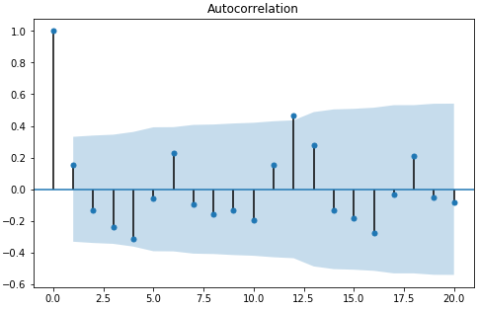

According to the above the differenced (1) data now looks more stationary and is a better result than the 12 differenced value; the autocorrelation function is now showing all previous lags are within the 95% confidence window, with the 12th lagged value just outside the confidence interval perhaps hinting at the annual seasonality being present.

## Augmented Dickey-Fuller test

One way to statistically determine the stationarity of time series data is to use the Augmented Dickey-Fuller test. I will use the adfuller function from the statsmodels library. The statsmodels documentation defines the function as:

*"The null hypothesis of the Augmented Dickey-Fuller is that there is a unit root, with the alternative that there is no unit root. If the pvalue is above a critical size, then we cannot reject that there is a unit root. The p-values are obtained through regression surface approximation from MacKinnon 1994, but using the updated 2010 tables. If the p-value is close to significant, then the critical values should be used to judge whether to reject the null."*

<http://www.statsmodels.org/dev/generated/statsmodels.tsa.stattools.adfuller.html>

I will test the original and differenced data to see if they are stationary.

* # Create function to run the Dickey-Fuller test
* **def** TestAdfuller(ts, cutoff = 0.01):
* ts_test = adfuller(ts, autolag = 'AIC')
* ts_test_output = pd.Series(ts_test[0:4], index=['Test Statistic','p-value','#Lags Used','Number of Observations Used'])
* **print**("p-value = ", ts_test[1])
* **print**("cutoff = ", cutoff,"\n")
* **print**("** Original data **")
* TestAdfuller(dfm['TaxiOut'])
* **print**("** Difference of lag 1 **")
* TestAdfuller(dfms['TaxiOut'])
* **print**("** Difference of lag 12 **")
* TestAdfuller(dfms12['TaxiOut'])

** Original data **

p-value = 0.0158231175438

cutoff = 0.01

** Difference of lag 1 **

p-value = 0.00143640489155

cutoff = 0.01

** Difference of lag 12 **

p-value = 0.0412516892753

cutoff = 0.01

We can see that only the data differenced by one lag has strong evidence against the null hypothesis, meaning the data has no unit root, and is stationary The original and data differenced by 12 has weak evidence against the null hypothesis, meaning it is non-stationary.

# Choosing the model order

Before fitting any models I first need to separate the data into a test and training set as not to over fit the model. I will use the first two years for training and the third year for testing the forecast.

* # Split the data into train and test sets
* train = dfm[0:24]
* test = dfm[24:]

## Auto Regressive model analysis

An AR model of order 1 can be simply described as; a mean, plus a fraction (Φ) of the previous lagged value, plus noise. Higher orders of models take into account additional Φ values, for example;

**RA(1)**

Rt = μ + ϕRt-1 + εt

**RA(2)**

Rt = μ + ϕ1Rt-1 + ϕ2Rt-2 + εt

**RA(3)**

Rt = μ + ϕ1Rt-1 + ϕ2Rt-2 + ϕ3Rt-3 + εt

Each value of Φ needs to be between -1 and 1 for stationarity.

If Φ is negative this implies mean reversion; i.e. if the value at T-1 is positive, then a negative Φ means that the value at T0 would be negative. If Φ is positive this implies trend following (momentum); i.e. if the value at T-1 is positive, then a positive Φ means that the value at T0 would be positive.

Using an autocorrelation function, the value decreases exponentially at a rate of Φ, e.g. if Φ = 0.9, the lag 1 autocorrelation is 0.9, the lag 2 autocorrelation is 0.92, the lag 3 autocorrelation is 0.93 etc. If Φ is negative then the sign of the autocorrelation values are inverted at each lag.

## Estimate the Order of the AR Model - Partial Autocorrelation method

The order of the model (p) needs to be determined before running the model. The Partial Autocorrelation Function (PACF) is a useful tool to identify this value. The results are interpreted as follows: For a p value of 1, the PACF should have a significant lag-1 value, and values close to zero after that. For a p value of 2, the PACF result should have significant lag 1 and lag 2 values, and values close to zero after that.

* # Plot pacf
* plt.rcParams['figure.figsize'] = [8.0, 5.0]
* plot_pacf(train.TaxiOut, lags=20)

We can see from the above plots that a good starting point for model selection would be an AR(2) model. There is also some autocorrelation at lag 7 which may be useful to try later.

## Estimate the Order of the AR Model - Information Criteria methods AIC and BIC

Akaike Information Criterion (AIC) and the Bayesian Information Criterion (BIC) are two measures used to compute the goodness of fit using estimated parameters. A penalty function is also applied on the number of parameters.

* # Fit the data to an AR model with a p value between 0 and 7 and store the resultant BIC
* plt.rcParams['figure.figsize'] = [8.0, 5.0]
* BIC = np.zeros(8)
* **for** p **in** range(8):
* mod = ARIMA(train, order=(p,0,0))
* res = mod.fit()
* # Save BIC
* BIC[p] = res.bic
* # Plot the BIC over p
* plt.plot(range(1,8), BIC[1:8], marker='o', color = "blue")
* plt.xlabel('AR(p)')
* plt.ylabel('Bayesian Information Criterion')
* plt.show()

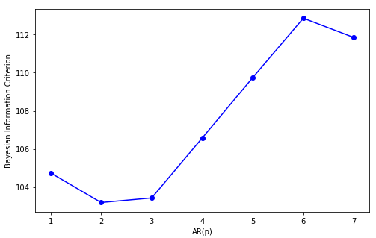

* # Fit the data to an AR model with a p value between 0 and 7 and store the resultant AIC
* plt.rcParams['figure.figsize'] = [8.0, 5.0]
* AIC = np.zeros(8)
* **for** p **in** range(8):
* mod = ARIMA(train, order=(p,0,0))
* res = mod.fit()
* # Save AIC
* AIC[p] = res.aic
* # Plot the AIC over p
* plt.plot(range(1,8), AIC[1:8], marker='o', color = "blue")
* plt.xlabel('AR(p)')
* plt.ylabel('Akaike Information Criterion')
* plt.show()

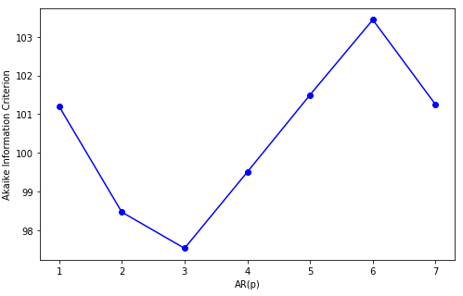

We can see from the above plots that an AR(2) model has the lowest BIC, and an AR(3) model has the lowest AIC value; we can look at the difference between these two order choices later to see which is optimum.

## Moving Average model analysis

An MA(1) model can be simply described as; a mean, plus noise plus a fraction (θ) of the previous lagged noise value. Higher orders of models take into account additional θ values, if the value of θ is 0 then the generator of the data is white noise.

**MA(1) model**

Rt = μ + ϵt1 + θϵt-1

If θ is negative this implies mean reversion; i,e. if the value at T-1 is positive, then a negative θ means that the value at T0 would be negative. If θ is positive this implies trend following (momentum); i,e. if the value at T-1 is positive, then a positive θ means that the value at T0 would be positive.

Using an autocorrelation function, unlike an AR(1) model, an MA(1) model will not have any (significant) values above 0 beyond lag 1, i.e. an MA(q) model has no autocorrelation beyond lag q. It is also worth noting that the lag 1 autocorrelation value for an MA(1) model is not θ, but θ/(1+θ²), if the value of θ is negative then the value at lag 1 would be -θ/(1+(-θ)²)

## Estimate the Order of the MA Model - Autocorrelation method

Correlation is used to compare two different observations, whereas autocorrelation is the correlation of a time series with a lagged copy of itself. If a time series has a negative autocorrelation it is known as mean reverting, and if it has positive autocorrelation it is known as trend following or that it has positive momentum. Autocorrelation can be used to estimate the q value of an MA model. I use the acf function from the statsmodels library below to plot the results with the default confidence level of 95%.

* # Plot the acf function
* plt.rcParams['figure.figsize'] = [8.0, 5.0]
* plot_acf(train.TaxiOut, lags=20)
* plt.show()
* autocorrelation = train['TaxiOut'].autocorr()
* **print**("Autocorrelation of Taxi Out = ", autocorrelation)

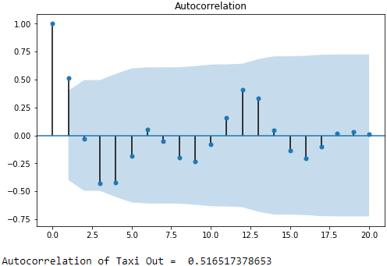

We can see the seasonal element coming out around 12 lags, we can also conclude that there is some positive correlation to the 2nd lag value. The 1st lag value is the only one outside of the 95% confidence area (blue shaded area), meaning that only this value is significant, i.e. The lag value T-1 is positively correlated to the value at T0. A value of 1 should be used for the MA model parameter q.

# Fitting and evaluating the model

Now we have explored each element of the ARIMA model and have some recomended parameter values, we can fit the model to the data and evaluate how each model performs. I will use the statsmodels library for my ARIMA model; the model is created as follows:

1. Create the model by calling ARIMA() and passing in the required p, d, and q parameters.
2. The model is trained by calling the fit() function.
3. Predictions are made by calling the predict() function and specifying the range or index of the time values to be predicted.

To evaluate the model I will examine the residuals, which should haven no patterns and be normally distributed. I can also use an ACF plots for the residuals; I would expect no significant values in the autocorrelation plot if the parameters are good. I will also visualy examine the prediction plot for each version of the model.

## Train the model with each combination of parameters

* # AR(2) model, turning off the I and MA components of the ARIMA model with 0 d and q values.
* p = 2
* d = 0
* q = 0
* mod200 = ARIMA(train, order=(p,d,q))
* res200 = mod200.fit()
* # AR(3) model to see how this compares to AR(2), turning off the I and MA components of the ARIMA model with 0 d and q values.
* p = 3
* d = 0
* q = 0
* mod300 = ARIMA(train, order=(p,d,q))
* res300 = mod300.fit()
* # ARIMA(2,1,0) I will now add a differencing of 1 to the AR(2) model
* p = 2
* d = 1
* q = 0
* mod210 = ARIMA(train, order=(p,d,q))
* res210 = mod210.fit()
* # ARIMA(3,1,0) I will now add a differencing of 1 to the AR(2) model
* p = 3
* d = 1
* q = 0
* mod310 = ARIMA(train, order=(p,d,q))
* res310 = mod310.fit()
* # MA(1) model, turning off the AR and I components of the ARIMA model with 0 value p and d values.
* p = 0
* d = 0
* q = 1
* mod001 = ARIMA(train, order=(p,d,q))
* res001 = mod001.fit()
* # ARIMA(0,1,1) I will now add a differencing of 1 to the MA(1) model
* p = 0
* d = 1
* q = 1
* mod011 = ARIMA(train, order=(p,d,q))
* res011 = mod011.fit()
* # ARIMA(2,1,1)
* p = 2
* d = 1
* q = 1
* mod211 = ARIMA(train, order=(p,d,q))
* res211 = mod211.fit()
* # ARIMA(3,1,1)
* p = 3
* d = 1
* q = 1
* mod311 = ARIMA(train, order=(p,d,q))
* res311 = mod311.fit()

## Plot the forecast of each model

* # Define the prediction start and end months
* predstart = 1
* predend = 28
* plt.rcParams['figure.figsize'] = [16.0, 20.0]
* ax1 = plt.subplot(4, 2, 1)
* ax2 = plt.subplot(4, 2, 2)
* ax3 = plt.subplot(4, 2, 3)
* ax4 = plt.subplot(4, 2, 4)
* ax5 = plt.subplot(4, 2, 5)
* ax6 = plt.subplot(4, 2, 6)
* ax7 = plt.subplot(4, 2, 7)
* ax8 = plt.subplot(4, 2, 8)
* # AR(2)
* fig = res200.plot_predict(start=predstart, end=predend, ax = ax1)
* ax1.set_title("AR(2) Model Prediction")
* # AR(3)
* res300.plot_predict(start=predstart, end=predend, ax = ax2)
* ax2.set_title("AR(3) Model Prediction")
* # ARIMA(2,1,0)
* res210.plot_predict(start=predstart, end=predend, ax = ax3)
* ax3.set_title("ARIMA(2,1,0) Model Prediction")
* # ARIMA(3,1,0)
* res310.plot_predict(start=predstart, end=predend, ax = ax4)
* ax4.set_title("ARIMA(3,1,0) Model Prediction")
* # MA(1)
* res001.plot_predict(start=predstart, end=predend, ax = ax5)
* ax5.set_title("MA(1) Model Prediction")
* # ARIMA(0,1,1)
* res011.plot_predict(start=predstart, end=predend, ax = ax6)
* ax6.set_title("ARIMA(0,1,1) Model Prediction")
* # ARIMA(2,1,1)
* res211.plot_predict(start=predstart, end=predend, ax = ax7)
* ax7.set_title("ARIMA(2,1,1) Model Prediction")
* # ARIMA(3,1,1)
* res311.plot_predict(start=predstart, end=predend, ax = ax8)
* ax8.set_title("ARIMA(3,1,1) Model Prediction")
* plt.show()

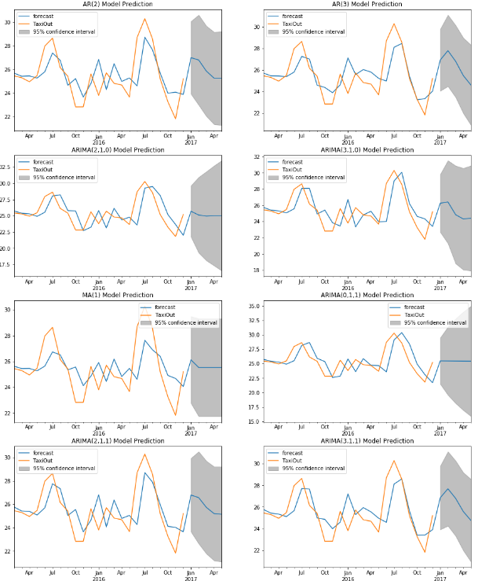

* plt.rcParams['figure.figsize'] = [15.0, 35.0]
* ax1 = plt.subplot(8, 2, 1)
* ax2 = plt.subplot(8, 2, 2)
* ax3 = plt.subplot(8, 2, 3)
* ax4 = plt.subplot(8, 2, 4)
* ax5 = plt.subplot(8, 2, 5)
* ax6 = plt.subplot(8, 2, 6)
* ax7 = plt.subplot(8, 2, 7)
* ax8 = plt.subplot(8, 2, 8)
* ax9 = plt.subplot(8, 2, 9)
* ax10 = plt.subplot(8, 2, 10)
* ax11 = plt.subplot(8, 2, 11)
* ax12 = plt.subplot(8, 2, 12)
* ax13 = plt.subplot(8, 2, 13)
* ax14 = plt.subplot(8, 2, 14)
* ax15 = plt.subplot(8, 2, 15)
* ax16 = plt.subplot(8, 2, 16)
* # AR(2)
* residuals = pd.DataFrame(res200.resid)
* residuals.plot(title = "AR(2) Residuals",kind='density', ax = ax1)
* plot_acf(residuals,title = "AR(2) Autocorrelation - Residuals", ax = ax2)
* # AR(3)
* residuals = pd.DataFrame(res300.resid)
* residuals.plot(title = "AR(3) Residuals",kind='density', ax = ax3)
* plot_acf(residuals,title = "AR(3) Autocorrelation - Residuals", ax = ax4)
* # ARIMA(2,1,0)
* residuals = pd.DataFrame(res210.resid)
* residuals.plot(title = "ARIMA(2,1,0) Residuals",kind='density', ax = ax5)
* plot_acf(residuals,title = "ARIMA(2,1,0) Autocorrelation - Residuals", ax = ax6)
* # ARIMA(3,1,0)
* residuals = pd.DataFrame(res310.resid)
* residuals.plot(title = "ARIMA(3,1,0) Residuals",kind='density', ax = ax7)
* plot_acf(residuals,title = "ARIMA(3,1,0) Autocorrelation - Residuals)", ax = ax8)
* # MA(1)
* residuals = pd.DataFrame(res001.resid)
* residuals.plot(title = "MA(1) Residuals",kind='density', ax = ax9)
* plot_acf(residuals,title = "MA(1) Autocorrelation - Residuals", ax = ax10)
* # ARIMA(0,1,1)
* residuals = pd.DataFrame(res011.resid)
* residuals.plot(title = "ARIMA(0,1,1) Residuals",kind='density', ax = ax11)
* plot_acf(residuals, title = "ARIMA(0,1,1) Autocorrelation - Residuals", ax = ax12)
* # ARIMA(2,1,1)
* residuals = pd.DataFrame(res211.resid)
* residuals.plot(title = "ARIMA(2,1,1) Residuals", kind='density', ax = ax13)
* plot_acf(residuals, title = "ARIMA(2,1,1) Autocorrelation - Residuals", ax = ax14)
* # ARIMA(3,1,1)
* residuals = pd.DataFrame(res311.resid)
* residuals.plot(title = "ARIMA(3,1,1) Residuals", kind='density', ax = ax15)
* plot_acf(residuals, title = "ARIMA(3,1,1) Autocorrelation - Residuals", ax = ax16)
* plt.show()

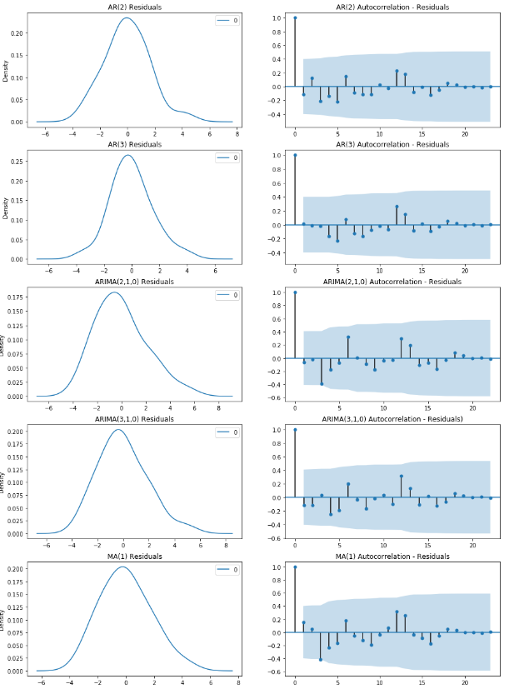

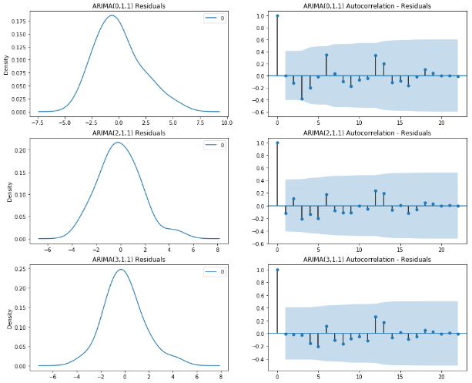

The residuals are generally Gaussian, centred around 0, with some variation, and the autocorrelation doesn't exhibit any significant correlation with lagged values. This suggests that the model is fairly effective and there shouldn’t be any seasonal processes not taken care of by the model.

Below I create a grid to compare the results of the models implemented.

* resdf = pd.DataFrame([res200.params[0], res200.params[1], res200.aic, res200.bic]).T.rename(index={0:'AR(2)'})
* resdf = resdf.append(pd.DataFrame([res300.params[0], res300.params[1], res300.aic, res300.bic]).T.rename(index={0:'AR(3)'}))
* resdf = resdf.append(pd.DataFrame([res210.params[0], res210.params[1], res210.aic, res210.bic]).T.rename(index={0:'ARIMA(2,1,0)'}))
* resdf = resdf.append(pd.DataFrame([res310.params[0], res310.params[1], res310.aic, res310.bic]).T.rename(index={0:'ARIMA(3,1,0)'}))
* resdf = resdf.append(pd.DataFrame([res001.params[0], res001.params[1], res001.aic, res001.bic]).T.rename(index={0:'MA(1)'}))
* resdf = resdf.append(pd.DataFrame([res211.params[0], res211.params[1], res211.aic, res211.bic]).T.rename(index={0:'ARIMA(2,1,1)'}))
* resdf = resdf.append(pd.DataFrame([res311.params[0], res311.params[1], res311.aic, res311.bic]).T.rename(index={0:'ARIMA(3,1,1)'}))
* resdf = resdf.rename(columns={0:'μ',1:'ϕ',2:'AIC',3:'BIC'})
* resdf

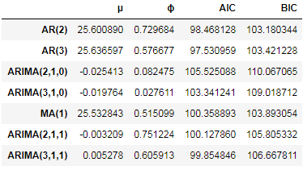

The mean is around 25 which is as expected and the ARIMA(2,1,0) model has the highest Φ value.

According to the above AIC and BIC results the best fit should be an AR(2) model or an AR(3) model. Visually I think the ARIMA(3,1,0) model is most appealing. The AIC and BIC use a penalty on the complexity of the model so perhaps that is why the simpler AR models are coming out with a lower value than the ARIMA models.

# Conclusion

A long taxi time leads to passenger dissatisfaction, it also increases cost to the airline because of greater fuel burn. It is increasing over time and an important area for an airline operator to understand, and be able to forecast the Taxi Out time. According to NBC News:

*“The creep in taxi times is attributed to a series of changes: massive runway construction projects at some of the nation's busiest airports; schedule changes that increase the number of flights at peak hours; and new, distant runways that relieve congestion but require more time to reach.”*

<https://www.nbcnews.com/business/travel/real-reason-flying-takes-longer-airport-taxi-times-keep-growing-n468121>

In this document I have taken a publically available data source detailing taxi times in the US, and explored it using the data science process. I described how to implement an ARIMA model in python. I made good use of the pandas and statsmodels libraries and demonstrated how model parameters can be discovered, produced forecasts of the taxi out times and plotted the results. I also examined some metrics for scoring the models and how seasonal components are formed.

I learnt that there is an upward trend in Taxi Times at JFK, there is seasonal variation in the summer and winter, and other processes that produce further variation. The ARIMA model is a good start to forecasting Taxi times and an Autoregressive model with a p value of 2 or 3 produced the best results.

I think the model could be further optimised; perhaps using a Seasonal ARIMA model or accounting for further seasonal components. I could also explore further Airports and Airlines.

# Resources

**Python Data Wrangling**

By Chris Albon

<https://chrisalbon.com/python/data_wrangling/pandas_join_merge_dataframe/>

**Cutting aircraft taxi times by a minute at Heathrow could save airlines £30m**

By Carrie Harris

<https://nats.aero/blog/2013/09/cutting-aircraft-taxi-times/>

**The Real Reason Flying Takes Longer: Airport Taxi Times Keep Growing**

By Associated Press

<https://www.nbcnews.com/business/travel/real-reason-flying-takes-longer-airport-taxi-times-keep-growing-n468121>

**Forecasting, Structural Time Series Models and the Kalman Filter**

By Andrew C. Harvey <https://books.google.co.uk/books?hl=en&lr=&id=Kc6tnRHBwLcC&oi=fnd&pg=PR9&dq=structural+time+series&ots=I4SOUsVTJI&sig=KiLu3Mp_u76CdB3DBXP0PKCLINc#v=onepage&q=structural%20time%20series&f=false>

**How to Check if Time Series Data is Stationary with Python**

By Jason Brownlee

<https://machinelearningmastery.com/time-series-data-stationary-python/>

**How to Create an ARIMA Model for Time Series Forecasting with Python**

By Jason Brownlee

<https://machinelearningmastery.com/arima-for-time-series-forecasting-with-python/>

I**ntroduction to Time Series Analysis in Python**

By Rob Reider

<https://www.datacamp.com/courses/introduction-to-time-series-analysis-in-python>

**Manipulating Time Series Data in Python**

By Stefan Jansen

<https://www.datacamp.com/courses/manipulating-time-series-data-in-python>

**ARIMA Model Documentation**

By Josef Perktold, Skipper Seabold, Jonathan Taylor, statsmodels-developers. <http://www.statsmodels.org/stable/generated/statsmodels.tsa.arima_model.ARIMA.html>

**Decomposition of time series**

From Wikipedia

<https://en.wikipedia.org/wiki/Decomposition_of_time_series>

**Matplotlib Documentation**

By John Hunter, Darren Dale, Eric Firing, Michael Droettboom and the Matplotlib development team

<https://matplotlib.org/gallery/index.html>

# Appendix

## Data Dictionary

|  |  |
| --- | --- |
| Year | Year |
| Quarter | Quarter (1-4) |
| Month | Month |
| DayofMonth | Day of Month |
| DayOfWeek | Day of Week |
| FlightDate | Flight Date (yyyymmdd) |
| UniqueCarrier | Unique Carrier Code. When the same code has been used by multiple carriers, a numeric suffix is used for earlier users, for example, PA, PA(1), PA(2). Use this field for analysis across a range of years. |
| AirlineID | An identification number assigned by US DOT to identify a unique airline (carrier). A unique airline (carrier) is defined as one holding and reporting under the same DOT certificate regardless of its Code, Name, or holding company/corporation. |
| Carrier | Code assigned by IATA and commonly used to identify a carrier. As the same code may have been assigned to different carriers over time, the code is not always unique. For analysis, use the Unique Carrier Code. |
| TailNum | Tail Number |
| FlightNum | Flight Number |
| OriginAirportID | Origin Airport, Airport ID. An identification number assigned by US DOT to identify a unique airport. Use this field for airport analysis across a range of years because an airport can change its airport code and airport codes can be reused. |
| OriginAirportSeqID | Origin Airport, Airport Sequence ID. An identification number assigned by US DOT to identify a unique airport at a given point of time. Airport attributes, such as airport name or coordinates, may change over time. |
| OriginCityMarketID | Origin Airport, City Market ID. City Market ID is an identification number assigned by US DOT to identify a city market. Use this field to consolidate airports serving the same city market. |
| Origin | Origin Airport |
| OriginCityName | Origin Airport, City Name |
| OriginState | Origin Airport, State Code |
| OriginStateFips | Origin Airport, State Fips |
| OriginStateName | Origin Airport, State Name |
| OriginWac | Origin Airport, World Area Code |
| DestAirportID | Destination Airport, Airport ID. An identification number assigned by US DOT to identify a unique airport. Use this field for airport analysis across a range of years because an airport can change its airport code and airport codes can be reused. |
| DestAirportSeqID | Destination Airport, Airport Sequence ID. An identification number assigned by US DOT to identify a unique airport at a given point of time. Airport attributes, such as airport name or coordinates, may change over time. |
| DestCityMarketID | Destination Airport, City Market ID. City Market ID is an identification number assigned by US DOT to identify a city market. Use this field to consolidate airports serving the same city market. |
| Dest | Destination Airport |
| DestCityName | Destination Airport, City Name |
| DestState | Destination Airport, State Code |
| DestStateFips | Destination Airport, State Fips |
| DestStateName | Destination Airport, State Name |
| DestWac | Destination Airport, World Area Code |
| CRSDepTime | CRS Departure Time (local time: hhmm) |
| DepTime | Actual Departure Time (local time: hhmm) |
| DepDelay | Difference in minutes between scheduled and actual departure time. Early departures show negative numbers. |
| DepDelayMinutes | Difference in minutes between scheduled and actual departure time. Early departures set to 0. |
| DepDel15 | Departure Delay Indicator, 15 Minutes or More (1=Yes) |
| DepartureDelayGroups | Departure Delay intervals, every (15 minutes from <-15 to >180) |
| DepTimeBlk | CRS Departure Time Block, Hourly Intervals |
| TaxiOut | Taxi Out Time, in Minutes |
| WheelsOff | Wheels Off Time (local time: hhmm) |
| WheelsOn | Wheels On Time (local time: hhmm) |
| TaxiIn | Taxi In Time, in Minutes |
| CRSArrTime | CRS Arrival Time (local time: hhmm) |
| ArrTime | Actual Arrival Time (local time: hhmm) |
| ArrDelay | Difference in minutes between scheduled and actual arrival time. Early arrivals show negative numbers. |
| ArrDelayMinutes | Difference in minutes between scheduled and actual arrival time. Early arrivals set to 0. |
| ArrDel15 | Arrival Delay Indicator, 15 Minutes or More (1=Yes) |
| ArrivalDelayGroups | Arrival Delay intervals, every (15-minutes from <-15 to >180) |
| ArrTimeBlk | CRS Arrival Time Block, Hourly Intervals |
| Cancelled | Cancelled Flight Indicator (1=Yes) |
| CancellationCode | Specifies The Reason For Cancellation |
| Diverted | Diverted Flight Indicator (1=Yes) |
| CRSElapsedTime | CRS Elapsed Time of Flight, in Minutes |
| ActualElapsedTime | Elapsed Time of Flight, in Minutes |
| AirTime | Flight Time, in Minutes |
| Flights | Number of Flights |
| Distance | Distance between airports (miles) |
| DistanceGroup | Distance Intervals, every 250 Miles, for Flight Segment |
| CarrierDelay | Carrier Delay, in Minutes |
| WeatherDelay | Weather Delay, in Minutes |
| NASDelay | National Air System Delay, in Minutes |
| SecurityDelay | Security Delay, in Minutes |
| LateAircraftDelay | Late Aircraft Delay, in Minutes |
| FirstDepTime | First Gate Departure Time at Origin Airport |
| TotalAddGTime | Total Ground Time Away from Gate for Gate Return or Cancelled Flight |
| LongestAddGTime | Longest Time Away from Gate for Gate Return or Cancelled Flight |
| DivAirportLandings | Number of Diverted Airport Landings |
| DivReachedDest | Diverted Flight Reaching Scheduled Destination Indicator (1=Yes) |
| DivActualElapsedTime | Elapsed Time of Diverted Flight Reaching Scheduled Destination, in Minutes. The ActualElapsedTime column remains NULL for all diverted flights. |
| DivArrDelay | Difference in minutes between scheduled and actual arrival time for a diverted flight reaching scheduled destination. The ArrDelay column remains NULL for all diverted flights. |
| DivDistance | Distance between scheduled destination and final diverted airport (miles). Value will be 0 for diverted flight reaching scheduled destination. |
| Div1Airport | Diverted Airport Code1 |
| Div1AirportID | Airport ID of Diverted Airport 1. Airport ID is a Unique Key for an Airport |
| Div1AirportSeqID | Airport Sequence ID of Diverted Airport 1. Unique Key for Time Specific Information for an Airport |
| Div1WheelsOn | Wheels On Time (local time: hhmm) at Diverted Airport Code1 |
| Div1TotalGTime | Total Ground Time Away from Gate at Diverted Airport Code1 |
| Div1LongestGTime | Longest Ground Time Away from Gate at Diverted Airport Code1 |
| Div1WheelsOff | Wheels Off Time (local time: hhmm) at Diverted Airport Code1 |
| Div1TailNum | Aircraft Tail Number for Diverted Airport Code1 |
| Div2Airport | Diverted Airport Code2 |
| Div2AirportID | Airport ID of Diverted Airport 2. Airport ID is a Unique Key for an Airport |
| Div2AirportSeqID | Airport Sequence ID of Diverted Airport 2. Unique Key for Time Specific Information for an Airport |
| Div2WheelsOn | Wheels On Time (local time: hhmm) at Diverted Airport Code2 |
| Div2TotalGTime | Total Ground Time Away from Gate at Diverted Airport Code2 |
| Div2LongestGTime | Longest Ground Time Away from Gate at Diverted Airport Code2 |
| Div2WheelsOff | Wheels Off Time (local time: hhmm) at Diverted Airport Code2 |
| Div2TailNum | Aircraft Tail Number for Diverted Airport Code2 |
| Div3Airport | Diverted Airport Code3 |
| Div3AirportID | Airport ID of Diverted Airport 3. Airport ID is a Unique Key for an Airport |
| Div3AirportSeqID | Airport Sequence ID of Diverted Airport 3. Unique Key for Time Specific Information for an Airport |
| Div3WheelsOn | Wheels On Time (local time: hhmm) at Diverted Airport Code3 |
| Div3TotalGTime | Total Ground Time Away from Gate at Diverted Airport Code3 |
| Div3LongestGTime | Longest Ground Time Away from Gate at Diverted Airport Code3 |
| Div3WheelsOff | Wheels Off Time (local time: hhmm) at Diverted Airport Code3 |
| Div3TailNum | Aircraft Tail Number for Diverted Airport Code3 |
| Div4Airport | Diverted Airport Code4 |
| Div4AirportID | Airport ID of Diverted Airport 4. Airport ID is a Unique Key for an Airport |
| Div4AirportSeqID | Airport Sequence ID of Diverted Airport 4. Unique Key for Time Specific Information for an Airport |
| Div4WheelsOn | Wheels On Time (local time: hhmm) at Diverted Airport Code4 |
| Div4TotalGTime | Total Ground Time Away from Gate at Diverted Airport Code4 |
| Div4LongestGTime | Longest Ground Time Away from Gate at Diverted Airport Code4 |
| Div4WheelsOff | Wheels Off Time (local time: hhmm) at Diverted Airport Code4 |
| Div4TailNum | Aircraft Tail Number for Diverted Airport Code4 |
| Div5Airport | Diverted Airport Code5 |
| Div5AirportID | Airport ID of Diverted Airport 5. Airport ID is a Unique Key for an Airport |
| Div5AirportSeqID | Airport Sequence ID of Diverted Airport 5. Unique Key for Time Specific Information for an Airport |
| Div5WheelsOn | Wheels On Time (local time: hhmm) at Diverted Airport Code5 |
| Div5TotalGTime | Total Ground Time Away from Gate at Diverted Airport Code5 |
| Div5LongestGTime | Longest Ground Time Away from Gate at Diverted Airport Code5 |
| Div5WheelsOff | Wheels Off Time (local time: hhmm) at Diverted Airport Code5 |
| Div5TailNum | Aircraft Tail Number for Diverted Airport Code5 |